**Ex no: 2**

**Date: 02.03.2024**

**System Monitoring Using Shell Script**

**Aim:**

To write a Shellscript to to display system information. **Program:**

#!/bin/bash

# Sample script written for Part 4 of the RHCE series # This script will return the following set of system

information: # -Hostname information:

echo -e "\e[31;43m***** HOSTNAME INFORMATION *****\e[0m" hostnamectl

echo ""

# -File system disk space usage:

echo -e "\e[31;43m***** FILE SYSTEM DISK SPACE USAGE *****\e[0m" df -h

echo ""

# -Free and used memory in the system:

echo -e "\e[31;43m ***** FREE AND USED MEMORY *****\e[0m" free

echo ""

# -System uptime and load:

echo -e "\e[31;43m***** SYSTEM UPTIME AND LOAD *****\e[0m" uptime

echo ""

# -Logged-in users:

echo -e "\e[31;43m***** CURRENTLY LOGGED-IN USERS *****\e[0m" who

echo ""

# -Top 5 processes as far as memory usage is concerned echo -e "\e[31;43m***** TOP 5 MEMORY-CONSUMING PROCESSES *****\e[0m" ps -eo %mem,%cpu,comm --sort=-%mem | head -n 6 echo ""

echo -e "\e[1;32mDone.\e[0m"

**Output:**

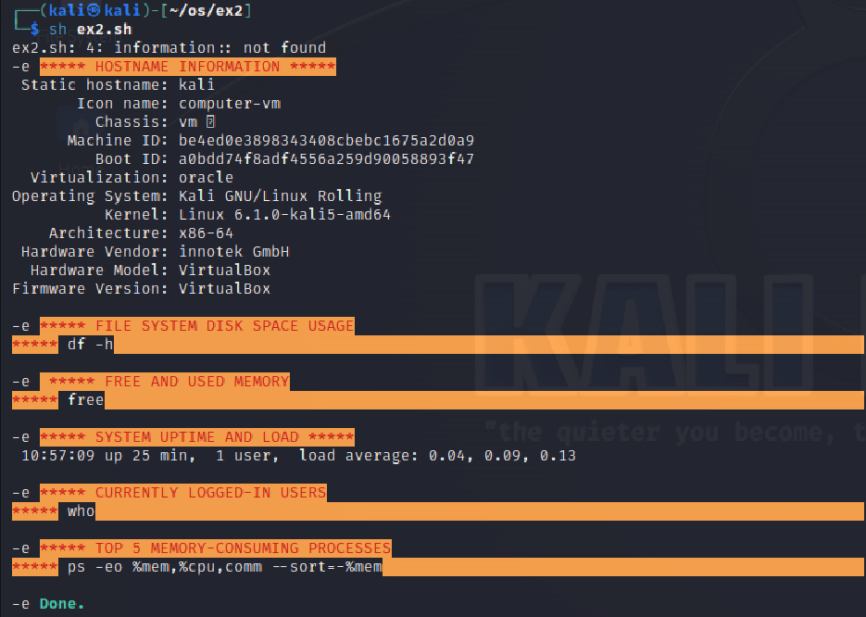

**Result:**

The above program executed successfully and output got verified.